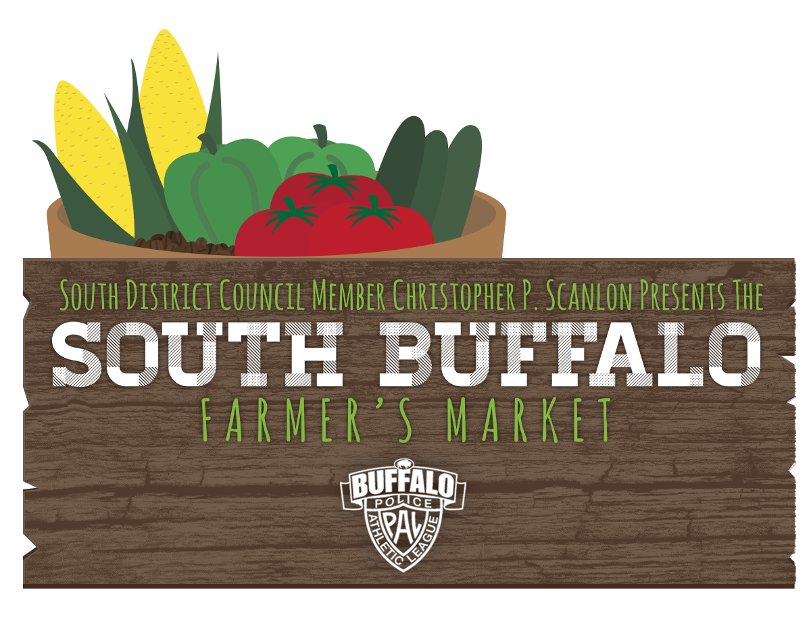
APPLICATION FOR SOUTH BUFFALO FARMERS MARKET 2022 CRAFT FAIRS
Vendors interested in participating in Craft Day should send their completed application and $25/day payment via Venmo (@SouthBuffalo-FarmersMarket) or check made out to The South Buffalo Farmers Market to:
The South Buffalo Farmers Market
205 McKinley Pkwy
Buffalo, NY 14220
Please do not submit payment until your application has been accepted

NAME:____________________________________________________________________________________________
BUSINESS NAME:____________________________________________________________________________________
ADDRESS:__________________________________________________________________________________________
__________________________________________________________________________________________________
TELEPHONE: Primary: _________________________________ Alternate: ____________________________________
EMAIL: ____________________________________________________________________________________________
What product(s) will you sell? _________________________________________________________________________
__________________________________________________________________________________________________
Please attach, enclose or link 3-4 Images of your merchandise (pictures can be emailed to the email address below, please include business name and day applying for in email)

Please check the date(s) you wish to participate: _____ June 26th. ______ September 11th

- The SBFM board will review all applications to make sure that products showcase original works of art and hand crafted items. No imports, re-sellers, or commercially-produced items will be accepted.
- Applications received without photos of your merchandise will not be sufficient to determine if the work conforms to SBFM guidelines above and will not be considered for inclusion in the Craft Show.
- Each craft vendor will be provided with a 10 ft. space.
- Craft vendors are responsible for bringing their own tables, chairs, canopies/tents, and any other equipment they require.
- The SBFM runs from 9AM -1PM. Set up beings at 7:30am. All vendors/organizations must be set up by 8:50am. Vendors are expected to stay the duration of the market and are responsible for cleaning up their area.
- Vendors/organizations can briefly pull into the traffic circle (10 minutes max) in front of the casino to unload, but vehicles must be moved and parked on the street. There is also plenty of space to park on the street and unload.
- Craft vendors are not guaranteed participation. Space is limited and granted on a first come, first serve basis.
- Craft vendors must submit payment prior to event date. Payment will NOT be accepted the day of. Fee is $25/date.

Questions? Email southbuffalofarmersmarket@gmail.com or call 851-5169.

